# Beef Nutrition!

Fill in the blanks during your class discussion about beef nutrition. Then, keep this worksheet to reference later!

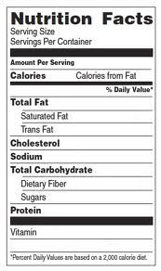

**What food group is beef in?**

dairy or protein (circle one)

**Can beef be a part of a healthy diet?**

**What makes beef healthy or unhealthy?**

**Do you like to eat beef?**

s:

Other notes to remember:

**My beef product: My group members:**